**The input image for the lab was:**

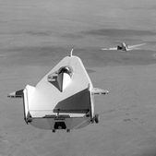

**For Output-01:**

Here the given image from result-01 is:

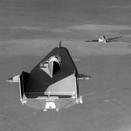

The compared image of the result-01 and negative transformed image from code:

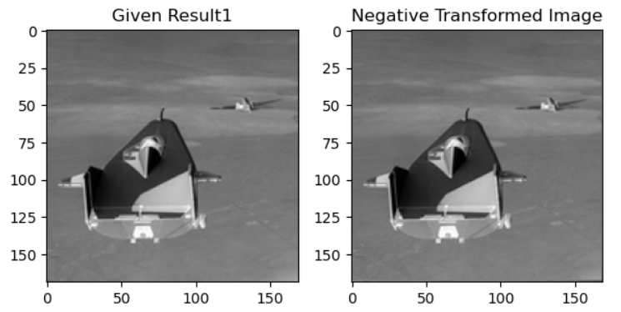

The difference image of these two by code is:

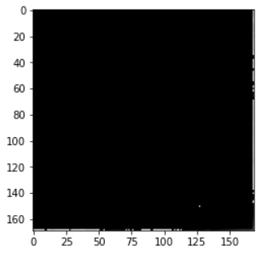

So we can understand the operation which was done on input image to produce result-01 was negative transformation. So the pixel values in the output image are inverted from the input one by mathematical function, s = L-1-r, where s is the final intensity and r is the initial intensity. So this produces a photographic negative.

**For Output-02:**

Here the given image from result-02 is:

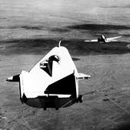

The compared image of the result-02 and contract stretched image from code:

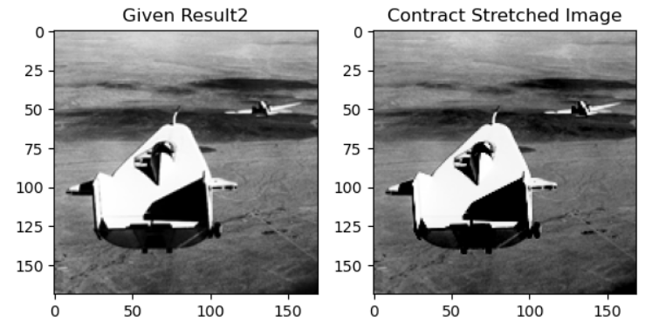

The difference image of these two by code is:

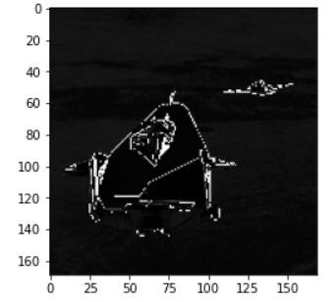

So we can understand the operation which was done on input image to produce result-02 was contract stretching. The contrast range of the output image is increased by the formula i_max-i_min/(i_max+i_min). The histogram of the input image had pixels from 110 to 170. So these pixels were stretched from 0 to 240 in the output image.

**For Output-03:**

Here the given image from result-03 is:

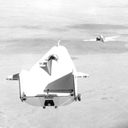

The compared image of the result-03 and log transformed image from code:

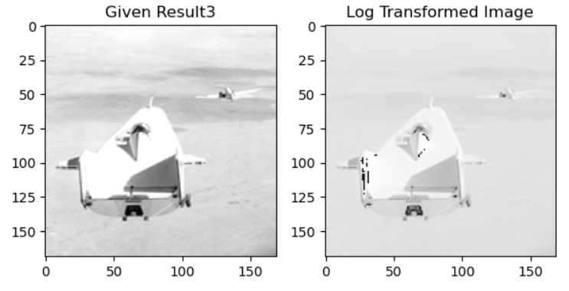

The difference image of these two by code is:

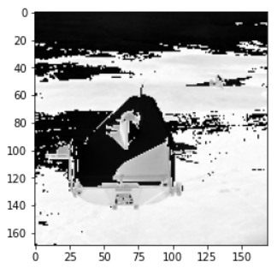

So we can understand the operation which was done on input image to produce result-03 was log transformation. This is followed by the logarithmic curve. Mathematically, s = c*log(1+r), here c is the scaling constant. So this is logarithmic transformation.

**For Output-04:**

Here the given image from result-04 is:

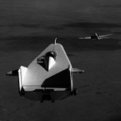

The compared image of the result-04 and gamma transformed image from code:

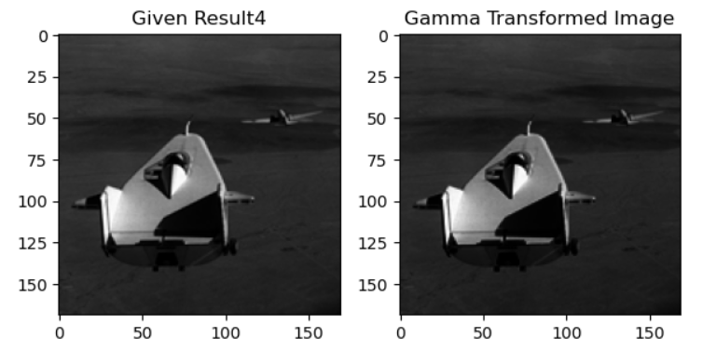

The difference image of these two by code is:

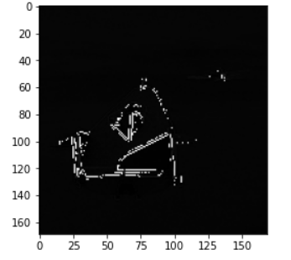

So we can understand the operation which was done on input image to produce result-04 was gamma transformation. Here the value of gamma is taken as 3.2 in the equation, s = (c* r ^ gamma). Intensity values of bright ones as well as dark are decreased. Bright ones became dark and dark ones became darker in the output image. So this is gamma transformation.